RISK MANAGEMENT PLANS 18/04/24
EVERY patient should have a risk management plan – this should be completed within 24 hours of admission.
GUIDE ON CONTENT:
This must be titled “RISK MANAGEMENT PLAN” – this needs to include:
- What the risk is e.g self harm/ risk to others/ violence and aggression
- How it presents and what the signs are it is occuring specifics on ligature/ cutting/ pacing
- How we should manage this risk when it occurs e.g 1:1 time, patient to hand over risk items and full search to be completed, PRN to be offered, spend time off of the ward, medical review, arrange a risk strategy meeting
- How to try to prevent or reduce it e.g de-escalation techniques including time spent doing certain activities
- How we know this has been reduced e.g example of reduced self-harm incidents or patient voicing they feel safer
- FINAL POINT TO BE INCLUDED FOR ALL PATIENTS: If risk management plan is unsuccessful and risk of self-harm continues to increase, review as MDT
PLEASE COPY AND PASTE THIS TEMPLATE INTO SYSTEM ONE:
RISK MANAGEMENT PLAN
WHAT IS THE RISK –
HOW DOES THIS PRESENT –
HOW TO PREVENT/ REDUCE –
EVALUATE SIGNS OF RISK REDUCTION –
NEXT STEPS IF RISK MANAGEMENT PLAN UNSUCCESSFUL -
WHERE SHOULD THIS BE:
- Retrieve patient
- Click on the launch pad
- Open a new “safety plan/ crisis plan”
- Complete all questions
- On Question 8 “Is there any other way to reduce risks and make you / others feel safer? Contingency / crisis Plan:” write the patient’s answer to this
- Click the black arrows next to the green speech button to the right of this box
- Click “assessor”
- Follow guide on content above with copied template 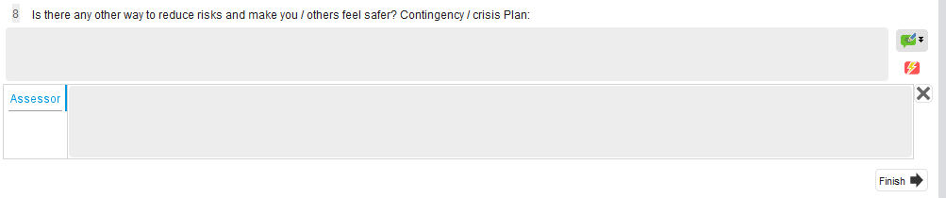
- Save as final version

